**GREENWOOD COLLEGE**

**Mathematics Methods Units 3 & 4**

**Test 1 Applications of Differentiation 2019**

Name Mark /24

**All electronic devices must be switched off and in bags.**

**Access to Formulae Sheet allowed. No notes.**

**No calculators allowed in this section. Time limit 25 minutes.**

**1. [ 4 marks ]**

Giving your answer in factored form, use the product rule to differentiate

$$f\left(x\right)=(1+x^{2}){(1+2x)}^{3}$$

**2. [ 4,2,1 = 7 marks ]**

**a)** If $y=\frac{2\sqrt{x}}{1-x}$ give a simplified expression (in fraction form) for $\frac{dy}{dx}$.

**b)** For what values of $x$ is $y$

**i)** undefined ? **ii)** zero ?

**3. [ 5,4 = 9 marks ]**

A curve has the equation $y=3x^{4}-8x^{3}+6x^{2}$.

**a)** Determine the coordinates of the stationary point(s) of this curve. Use the second derivative to determine their nature.

**b)** The curve has two inflection points, one of which is located at $x=1$.

Determine the coordinates of the second point of inflection.

**4. [ 5 marks ]**

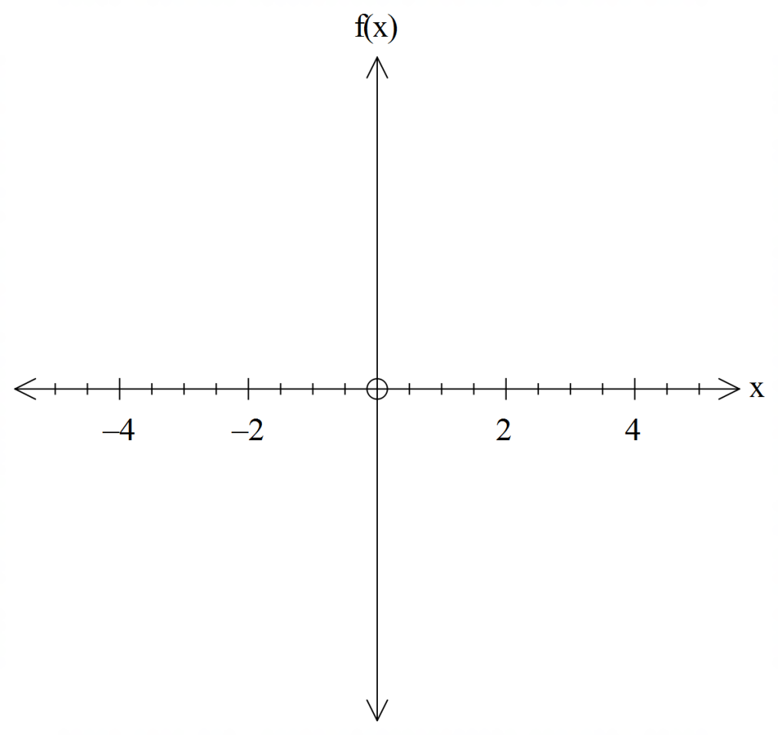Sketch the graph of $y=f(x)$ given the following properties:

* $\frac{dy}{dx}<0$ for $x<0$ and $0<x<2$
* $\frac{dy}{dx}=0$ for $x=2$
* $\frac{dy}{dx}>0$ for $x>2$
* $y=\frac{d^{2}y}{{dx}^{2}}$ =0 for $x=-1$
* $y$ is undefined for $x=0$

**GREENWOOD COLLEGE**

**Mathematics Methods Units 3 & 4**

**Test 1 Applications of Differentiation 2019**

Name Mark /30

**All electronic devices must be switched off and in bags.**

**Access to Formulae Sheet and one sheet of A4 notes allowed. Use of approved calculators is assumed in this section. Time limit 30 minutes.**

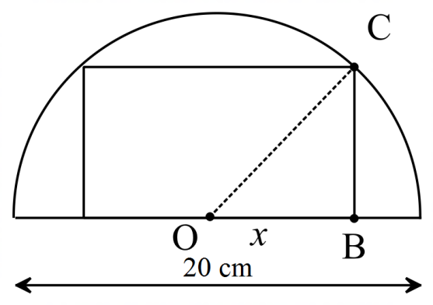**5. [ 7,1 = 8 marks ]**

Infinitely many rectangles can be inscribed in a semi-circle of diameter 20 cm.

**a)** Use calculus techniques to determine the dimensions of the rectangle with the largest area.

(Hint: Consider triangle OBC with $x=OB$)

**b)** State the area of your selected rectangle.

**6. [ 4,2 = 6 marks ]**

Helium gas is being pumped into a balloon. The balloon maintains a spherical shape as it inflates, and its volume increases at a constant rate of 600 cubic centimetres per minute.

1. At what rate is the radius of the balloon increasing when the volume of the balloon is 20 litres ? (1 litre = 1000 cm3 and )
2. Use the small increment formula to estimate the amount by which the radius will increase in the next second.

**7. [ 2,4,2,2 = 10 marks ]**

A particle moves in a straight line with a displacement function $x\left(t\right)=12t-2t^{3}-1$ cm,

where $t$ is in seconds, $t≥0$.

**a)** Give velocity and acceleration functions for the particle’s motion.

**b)** State the initial conditions of this particle’s motion, and interpret their meaning

**c)** When and where does the particle change direction ?

At what time is the particle’s

**i)** speed increasing **ii)** velocity increasing

**8. [ 4,2 = 6 marks ]**

The sales manager of a car yard estimates that the number of cars sold by his staff will be 80 next month. Bonuses and other incentives mean that the profit function for car sales is given by

$P\left(n\right)=2000n+10n^{2}$

In dollars, where $n$ is the number of cars sold in a month.

**a)** Use derivatives to find the error in profit if the manager’s estimate is out by 5%.

**b)** What percentage error in profit does this represent ?